**Project Design Phase-I Solution Architecture**

|  |  |
| --- | --- |
| Date | 04 October 2022 |
| Team ID | PNT2022TMID51379 |
| Project Name | Project – Plasma Donor Application |
| Maximum Marks | 2 Marks |

**Solution Architecture:**

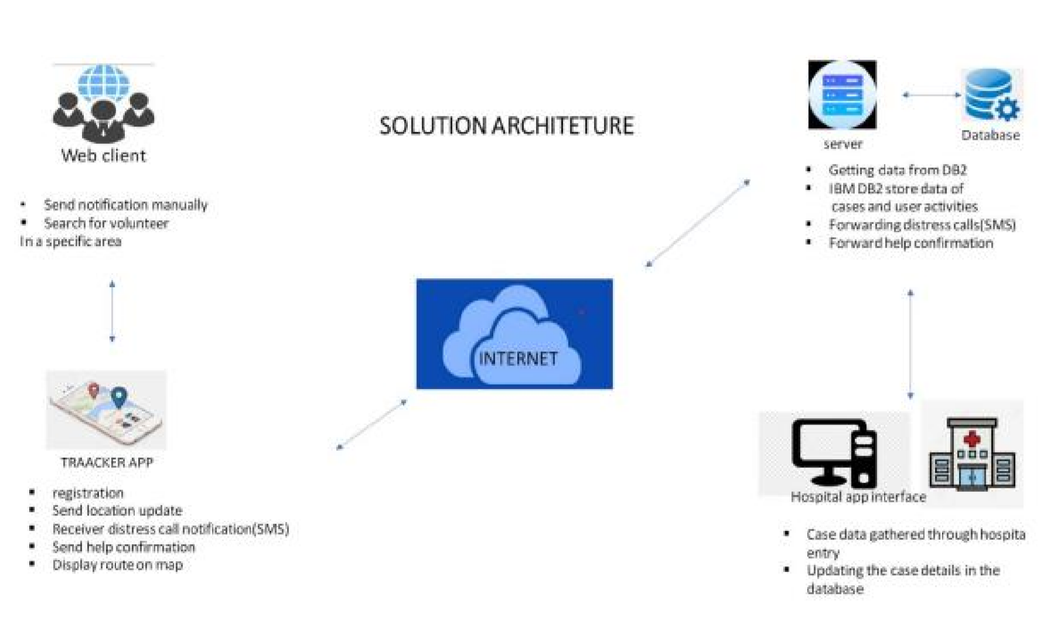

**Figure 1:** Architecture and data flow of the voice patient diary sample application